Mini project report on FILE COMPRESSION TOOL

Submitted in the partial fulfilment of the Requirements for the award of degree of
BACHELOR OF COMPUTER APPLICATION (BCA)
TO
Uttaranchal School of Computing Sciences (USCS)
UTTRANCHAL UNIVERSITY, DEHRADUN



Session 2025-2026

UNDER THE SUPERVISION OF: SUBMITTED BY:
MR. AAGAMAN KAPARWAN ABHAY KUMAR
ASSISTANT PROFESSOR Roll No- 2509000012

ACKNOWLEDGEMENT

First and foremost, I will be eternally grateful to God, to whom I owe my life. I'd also like to thank my parents for allowing me to attend Uttaranchal University in Dehradun. I'd like to convey my heartfelt appreciation to our Project Mentors, MR. AAGAMAN KAPARWAN
for their invaluable assistance in preparing the project and compiling the project materials. I am grateful for
their consistent blessings and for providing the necessary and related facilities for our computer project file. Most importantly. I'd also like to thank everyone who helped me finish my project, whether directly or indirectly.
Primarily I would like to thank Prof (Dr)Sonal Sharma, Director-USCS for providing a healthy and encouraging environment to study.
I profusely thankful to the Prof (Dr) Sameer Dev Sharma, HOD-USCS for providing all the required
resources in the successful completion of my project.

ABHAY KUMAR
UU-Roll-no. 2509000012
BCA II Sem

DECLARATION

I hereby declare that this project work entitled “FILE COMPRESSION TOOL” was submitted by ABHAY KUMAR to Uttaranchal School of Computing sciences. It is an authentic record of my work carried out at
“UTTARANCHAL UNIVERSITY” under the guidance of MR. AAGAMAN KAPARWAN

ABHAY KUMAR
UU-Roll-no. 2509000012
BCA II Sem

CERTIFICATE

This is to certify that the project entitled “FILE COMPRESSION TOOL” by ABHAY KUMAR has been submitted in the partial fulfilment of the requirements for the award of the degree of BCA-II from
Uttaranchal University, Dehradun. The results embodied in this project have not been submitted to any other University or Institution for the record of any degree.

UNDER THE GUIDANCE OF:
MR. AAGAMAN KAPARWAN
ASSISTANT PROFESSOR-USCS
UTTARANCHAL UNIVERSITY DEHRADUN

Table of Contents
ACKNOWLEDGEMENT
DECLARATION
CERTIFICATE OF ORIGINALITY

LIST OF Contents
- INTRODUCTION
- OBJECTIVE
- TOOLS/PLATFORM
- HARDWARE AND SOFTWARE REQUIREMENT
- NEED OF FILE COMPRESSION TOOL
- PERT CHART
- GANTT CHART
- DFD (0,1 LEVEL)
- CLASS DIAGRAM
- FILE COMPRESSION TOOL – PROJECT STRUCTURE
- PROCESS LOGIC OF EACH MODULE
- FUTURE SCOPE AND FURTHER ENHANCEMENT OF THE PROJECT
- BIBLIOGRAPHY

I

INTRODUCTION

File Compression Tool is a software application designed to reduce the size of files without losing important data. The main purpose of file compression is to save storage space and make file transfer faster and more efficient. Large files take more memory and require more time to send over the internet. By compressing files, we can minimize their size and improve system performance.
This project uses compression techniques such as Huffman Coding (or any other algorithm you used) to encode data efficiently. The tool reads the original file, analyses the frequency of characters, and converts the data into a compressed format. It can also decompress the file back to its original form when needed.
The File Compression Tool is useful in many real-world applications such as data storage, file sharing, cloud computing, and backup systems. This project helps in understanding important concepts like data structures, algorithms, file handling, and memory management in C++.

OBJECTIVES

The main objectives of the File Compression Tool project are:
- To reduce file size by using efficient compression algorithms.
- To save storage space in computers and other digital devices.
- To improve file transfer speed over networks by minimizing data size.
- To implement data compression techniques such as Huffman Coding (or the algorithm used) in C++.
- To understand file handling concepts including reading, writing, encoding, and decoding files.
- To enhance knowledge of data structures and algorithms used in real-world applications.
- To provide both compression and decompression features so that original data can be restored without loss.

Tools / Platform Used
- Programming Language: C++
- Platform: Windows / Linux
- Compiler: GCC / MinGW / Turbo C++ (or any standard C++ compiler) • IDE / Editor: Visual
Studio Code / Code::Blocks / Dev C++

Hardware Requirements
- Processor: Intel i3 or above
- RAM: Minimum 4 GB
- Hard Disk: 100 MB free space (for project files)
- Keyboard & Monitor

Software Requirement Specification (SRS)
- Operating System
  - Windows 7/8/10/11 or Linux
- Programming Language
  - C++
- Compiler
  - Any standard C++ compiler (GCC, MinGW, etc.)

4. Functional Requirements
- The system should allow the user to select a file for compression.
- The system should compress the file using a compression algorithm (e.g., Huffman Coding).
- The system should generate a compressed output file.
- The system should allow decompression of the compressed file.

5. Non-Functional Requirements
- The system should be user-friendly.
- The system should be efficient in reducing file size.
- The system should work with minimum hardware resource

Need of File Compression Tool
File compression is very important in today’s digital world where large amounts of data are stored and transferred daily. The need for a File Compression Tool arises due to the following reasons:
- Saves Storage Space: Large files occupy more memory. Compression reduces file size and saves disk space.
- Faster File Transfer: Smaller files can be uploaded, downloaded, and shared more quickly over the internet.
- Efficient Data Management: Compression helps in organizing and managing large data efficiently.
- Cost Reduction: Less storage space means reduced storage cost in cloud systems and servers.
- Backup and Archiving: Compressed files are easier to store and maintain for backup purposes.
- Improves System Performance: Smaller files require less processing time and bandwidth.

Requirement Specifications

1. Functional Requirements
- The system should allow the user to select or input a file.
- The system should compress the selected file using a compression algorithm (e.g., Huffman Coding).
- The system should generate a compressed file as output.
- The system should allow decompression of compressed files.
- The system should restore the original file without any data loss.
- The system should display file size before and after compression.

2. Non-Functional Requirements
- The system should be user-friendly and easy to operate.
- The system should provide accurate and reliable results.
- The compression and decompression process should be fast.
- The system should use minimum memory and CPU resources.

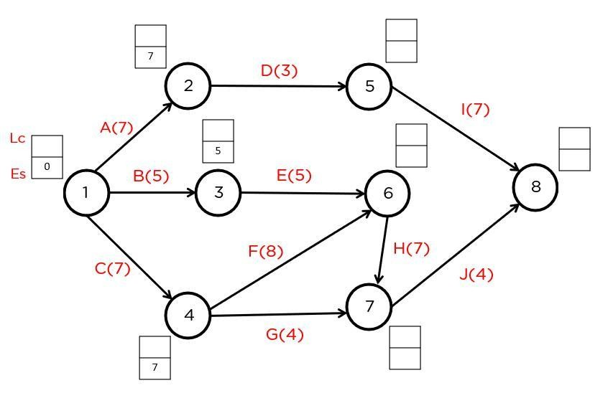
PERT Chart (Project Planning)

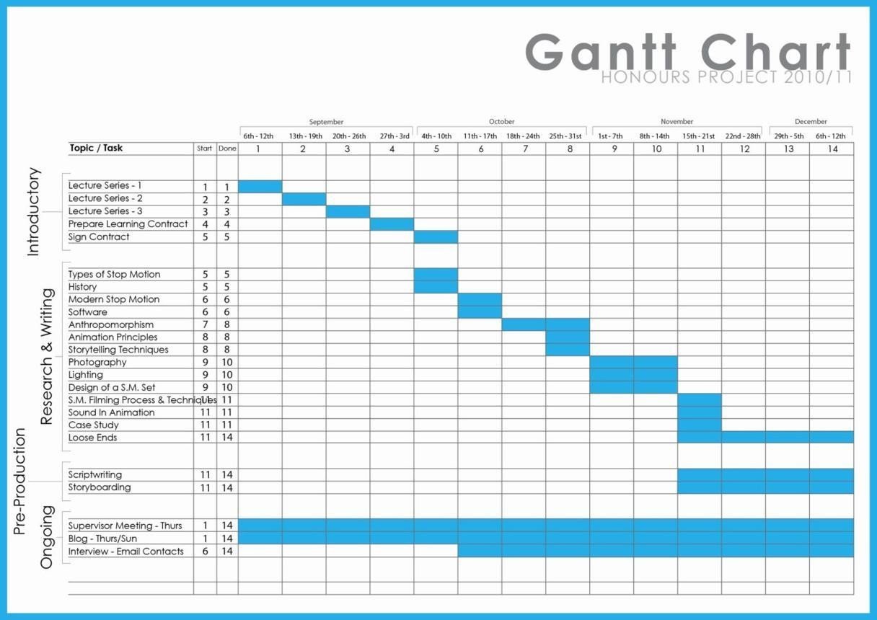
GANT CHART

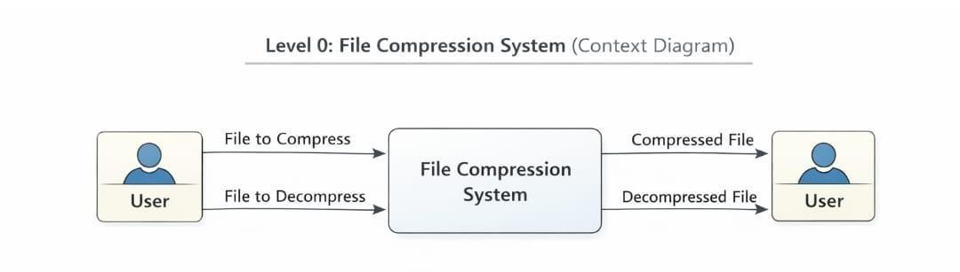
DFD (0 LEVEL)

Explanation

•

User

provides a file and selects compression or decompression.

•

File Compression System

processes the file.

•

Output is either a
compressed file

or the
original decompressed file

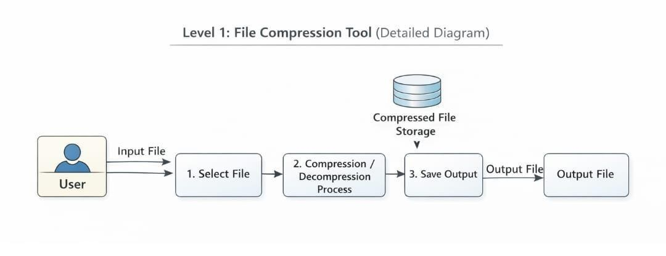
DFD (1 LEVEL) (Detailed Diagram)

Processes

1.

Input Handler

–

Accepts file and user command.

2.

Compression/Decompression Module

–

Performs algorithm (ZIP, Huffman, etc.).

Data Stores

•

Compressed File Storage

•

Decompressed File Storage

External Entity

•

User

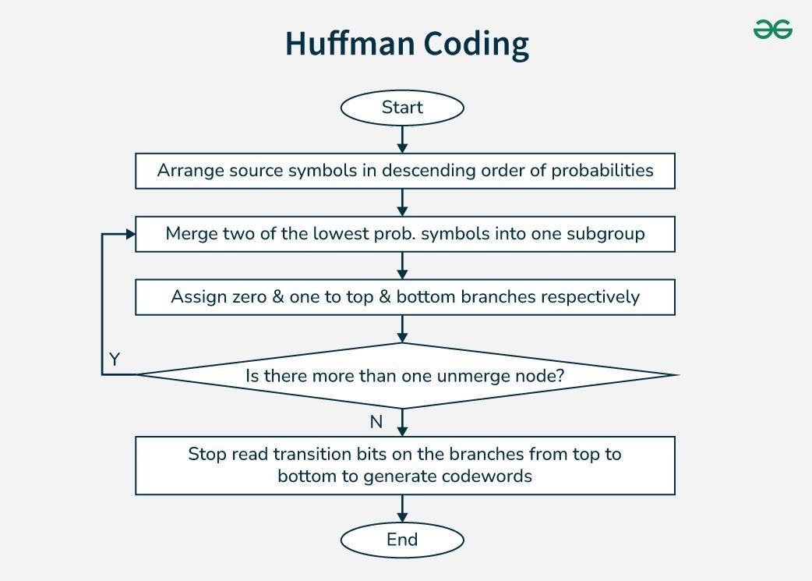
CLASS

DISGRAM

File Compression Tool – Project Structure

a) Number of Modules and Their Description

1. User Interface Module
- Allows the user to interact with the system.
- User selects the file and chooses Compress or Decompress option.
- Displays results and messages.

2. File Input Module
- Reads the file selected by the user.
- Checks file size and format.
- Loads the file data into memory for processing.

3. Compression Module
- Applies compression algorithm (example: Huffman Coding / ZIP).
- Converts original data into compressed format.
- Reduces file size.

4. Decompression Module
- Restores compressed file to its original form.
- Decodes compressed data using the same algorithm.

5. File Output Module
- Saves compressed or decompressed file.
- Generates output file with proper extension.

6. Error Handling Module
- Handles invalid file formats.
- Displays error messages.
- Prevents system crash.

b) Data Structures Used in the Project
- Array: Used to store file data temporarily.
- Structure: Used to store file details such as:
o File name o File size o Compression ratio.
Example:
struct File
{ char filename [50]; long
size;
};
- Tree (Optional – Huffman Coding)
• Used to store characters and frequency during compression.
4. Buffer
• Temporary storage while reading and writing file data.

Process Logic of Each Module

1. User Interface Module
- Start program.
- Display menu: o Compress File o Decompress File o Exit.
- Take user input.

2. File Input Module
- Ask user for file path.
- Open file.
- Read data into memory.

3. Compression Module
- Analyse file data.
- Apply compression algorithm.
- Generate compressed data.

4. Decompression Module
- Read compressed file.
- Decode data using algorithm.
- Restore original file content.

5. File Output Module
- Create new output file.
- Write compressed/decompressed data.
- Display success message.

6. Error Handling Module
- Check if file exists.
- Handle read/write errors.
- Display appropriate messages.

d) List of Reports Generated  - File Compression Report  - Original file size • Compressed file size  - Compression ratio.  - File Decompression Report  - Compressed file name  - Restored file size.  - Process Status Report  • Success or failure message.  - Error Report  - Invalid file • Unsupported format  - File not found. | 13

1.User Level Security
- User Authentication: Users must enter username and password to access the tool.
- Access Control: Only authorized users can compress or decompress files.
- User Validation: System checks whether the user is valid before allowing operations.

2. File Level Security
- File Permission Checking: The system checks if the user has permission to access the file.
- File Integrity Check: Ensures that the file is not corrupted before compression or decompression.
- Password Protected Files: Compressed files can be protected with a password.

3. Data Level Security
- Encryption: File data can be encrypted during compression to prevent unauthorized access.
- Secure Storage: Compressed files are stored in a secure location.
- Data Validation: Input data is checked to avoid errors or malicious files.

4. System Level Security
- Error Handling: Prevents system crashes due to invalid files or inputs.
- Virus/Malware Checking: Files are scanned before processing.
- Secure File Handling: Temporary files are deleted after processing.

5. Network Level Security (if tool works online)
- Secure Communication: Use encrypted protocols (HTTPS) while transferring files.
- Firewall Protection: Protects the system from unauthorized network access.

CODE

#include <iostream>
#include <fstream>
#include <map>
#include <queue> #include <string>
using namespace std;

// Node for Huffman Tree
struct Node { char ch; int freq;
Node *left, *right;

Node(char c, int f) {
ch = c; freq = f;
left = right = NULL;
}
};

// Compare for priority queue struct compare {
bool operator()(Node* l, Node* r) { return l->freq > r->freq;
}
};

// Generate Huffman Codes
void generateCodes(Node* root, string code, map<char, string> &huffmanCode) { if (!root) return;

if (!root->left && !root->right) {
huffmanCode[root->ch] = code;
}

generateCodes(root->left, code + "0", huffmanCode);
generateCodes(root->right, code + "1", huffmanCode);
}

// Build Huffman Tree Node* buildTree(string text) {
map<char, int> freq;

for (char ch : text) {
freq[ch]++;
}

priority_queue<Node*, vector<Node*>, compare> pq;

for (auto pair : freq) {
pq.push(new Node(pair.first, pair.second));
}

while (pq.size() != 1) {
Node *left = pq.top(); pq.pop();
Node *right = pq.top(); pq.pop();

Node *sum = new Node('\0', left->freq + right->freq); sum->left = left;
sum->right = right;

pq.push(sum);
}

return pq.top();
}

// Compress file
void compress(string inputFile, string outputFile) {
ifstream in(inputFile);
ofstream out(outputFile, ios::binary);

string text((istreambuf_iterator<char>(in)), istreambuf_iterator<char>());

Node* root = buildTree(text);

map<char, string> huffmanCode;
generateCodes(root, "", huffmanCode);

// Save codes (header) out << huffmanCode.size() << '\n'; for (auto pair : huffmanCode) {
out << pair.first << " " << pair.second << '\n';
}

// Encode text string encoded = "";
for (char ch : text) {
encoded += huffmanCode[ch];
}

out << encoded;

cout << "File Compressed Successfully!\n";
}

// Decompress file
void decompress(string inputFile, string outputFile) {
ifstream in(inputFile);
ofstream out(outputFile);

int size; in >> size;

map<string, char> reverseCode;
char ch; string code;

for (int i = 0; i < size; i++) { in >> ch >> code;
reverseCode[code] = ch;
}

string encoded, temp;
in >> encoded;

temp = ""; for (char bit : encoded) {
temp += bit;

if (reverseCode.count(temp)) { out << reverseCode[temp];
temp = "";
}
}

cout << "File Decompressed Successfully!\n";
}

// Main Menu int main() {
int choice;

cout << "1. Compress File\n"; cout << "2. Decompress File\n"; cout << "Enter choice: ";
cin >> choice;

if (choice == 1) {
compress("input.txt", "compressed.bin");
} else if (choice == 2) {
decompress("compressed.bin", "output.txt");
} else { cout << "Invalid Choice\n"; }

return 0;
}

OUTPUT

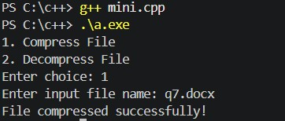

Future Scope and Further Enhancement of the Project (File Compression Tool)
- Support for Multiple File Formats
  - In the future, the tool can support more compression formats such as ZIP, RAR, 7z, and TAR.
- Improved Compression Algorithms
  - Advanced algorithms can be added to achieve higher compression ratios and faster processing.

3. Graphical User Interface (GUI)
o A user-friendly graphical interface can be developed to make the system easier to use instead of a command-line interface.

4. Password Protection and Encryption
o Security features like password protection and data encryption can be added to protect compressed files.
- Batch File Compression
  - The system can be enhanced to compress multiple files or folders at the same time.
- Cloud Integration
  - Files could be compressed and stored directly in cloud storage services.
- Automatic File Backup
  - The tool can create automatic backups before compression or decompression.

8. Cross-Platform Support
o The application can be developed to run on different operating systems such as Windows, Linux, and macOS.

9. File Size Optimization Reports
o Future versions can generate detailed reports showing compression ratio, space saved, and processing time.

Bibliography (File Compression Tool Project)
- E. Balagurusamy, Programming in ANSI C, Tata McGraw-Hill Education.
- Herbert Schildt, C: The Complete Reference, McGraw-Hill Education.
- Brian W. Kernighan and Dennis M. Ritchie, The C Programming Language, Prentice Hall.
- Ian Sommerville, Software Engineering, Pearson Education.
- Official C Programming Documentation – https://www.cprogramming.com
- Tutorials Point, “Data Compression Techniques” – https://www.tutorialspoint.com
- Geeks for Geeks, “File Compression Algorithms and Concepts” – https://www.geeksforgeeks.org

